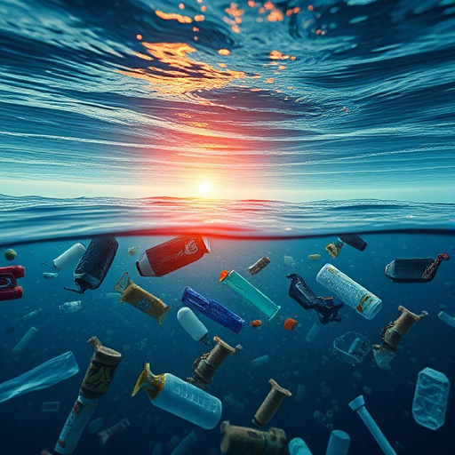

**Quantum-AI Enhanced Ocean Clean-up System**

The project tackles ocean Micro plastic pollution by optimising routes for clean-up systems.

NCEI Marine Microplastics product provides access to aggregated global data on microplastics in marine settings.

<https://www.ncei.noaa.gov/products/microplastics>

MAP :<https://experience.arcgis.com/experience/b296879cc1984fda833a8acc93e31476/page/Page/?views=Display-Filters%2CMap-Viewer#data_s=id%3AdataSource_1-18cf9a85fdd-layer-4%3A10466>

Here the image of a map  
points => the location of microplastic in the ocean.  
  
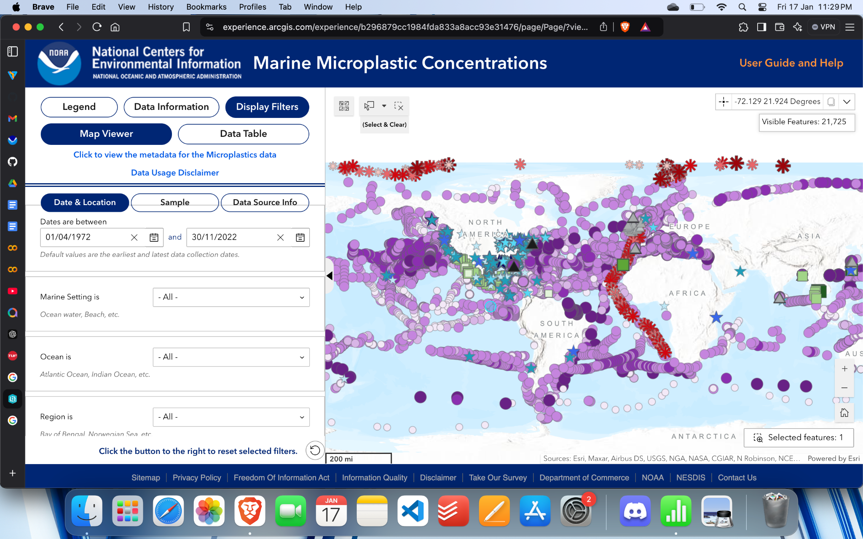

Sample data extracted from above map

| **OBJECTID** | **Latitude** | **Longitude** | **Microplastics Measurement (density)** | **Density Class Range** | **Concentration Class** |
| --- | --- | --- | --- | --- | --- |
| 8854 | 43.1094 | 3.1144 | 0.002 | 0.0005-0.005 | Low |
| 11091 | 43.0966 | 5.9917 | 0.78917 | 0.005-1 | Medium |
| 11092 | 43.1132 | 5.9279 | 1.95013 | 1-10 | High |
| 11093 | 43.077 | 5.9792 | 0.97608 | 0.005-1 | Medium |
| 11123 | 43.0951 | 5.9821 | 0.638818 | 0.005-1 | Medium |
| 11124 | 43.0779 | 6.1997 | 0.171411 | 0.005-1 | Medium |
| 11210 | 43.2842 | 5.2766 | 0.676127 | 0.005-1 | Medium |
| 11211 | 43.0879 | 5.7908 | 0.352637 | 0.005-1 | Medium |
| 11212 | 43.0941 | 5.98 | 0.525459 | 0.005-1 | Medium |
| 11213 | 43.0726 | 6.2372 | 4.75602 | 1-10 | High |

Below are few haversine distances measured between points   
  
Distance between location 1 and 2: 233.59 km

Distance between location 1 and 3: 228.38 km

**Note:**  
Haversine Distance:

* **Geolocation services**: Calculating distances between GPS coordinates.
* **Navigation**: Finding the shortest distance between two points on Earth's surface.
* **Logistics**: Optimizing delivery routes or calculating travel costs.

Microplastic location in ocean based on Latitude and Longitude

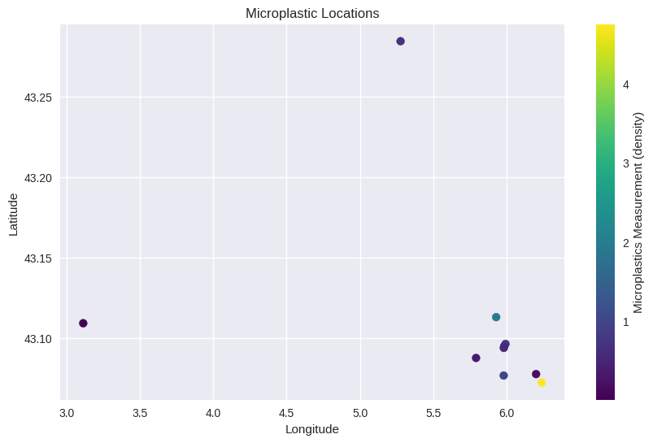

1. Based on the Cleaning system initial location ( can be decided by the cleaning organization)   
   We will optimize the cleaning system route with help of Quantum computer , using QAOA
2. Using AI model we can predict and pri-inform the cleaning system about weather, ocean current   
   Related information.

Q&A

What is QAOA ?

The **Quantum Approximate Optimization Algorithm (QAOA)** is a **hybrid quantum-classical algorithm** designed to solve **combinatorial optimization problems**. It works by:

1. **Mapping the problem** to a cost function (Hamiltonian), where the optimal solution corresponds to the lowest energy state (ground state).
2. Alternating between two quantum operations:
   * **Cost Hamiltonian evolution** (captures the problem constraints).
   * **Mixing Hamiltonian evolution** (explores the solution space).
3. Using a **classical optimizer** to fine-tune the parameters (γ,β\gamma, \beta) of the quantum circuit to minimize the cost function.

QAOA is particularly well-suited for problems like routing, scheduling, and resource allocation, and it is designed for near-term quantum devices due to its shallow circuit depth and robustness to noise.

Why are we using QAOA ?

**Problem Type:** Routing is a combinatorial optimization problem, perfectly suited for QAOA.

**Efficiency:** Finds the shortest, most energy-efficient routes while handling constraints.

**Scalability:** Adapts to both small and large-scale clean-up operations.